ROC’D
Rapid Online Course Development Project

Assessment Book

Checklists and Assessment Questions
For the Time Management Instructional Module:
Creating an Assignment
Creating and Assessment
Creating an Electronic Calendar

Use this book along with the instructional module.

Designed by:
Erin Gunter
Kevin Wi
Assessment Items
Pre-Test (Assessment tools for Entry Behaviors):

1. Do you know how to login to a Blackboard LMS account?
Yes

2. What are the qualities of a good assignment?
A. timeline
B. description
C. title
D. objective
3. What are the qualities of a good assessment?
The assessment accurately tests whether or not a learner has learned the material. The assessment only asks relevant questions that pertain to the information.

4. What is an open-ended item?
An item that poses a question where the student has to use their own words to answer a question.

5. What is a multiple choice item?
An item that has more than two answers to choose from in order to answer the question. The student must identify the correct answer by choosing the best answer for the question from the possible answers.

6. What is a matching item?
An item that has statement or questions that match with only one answer. The student must identify the correct matching pairs.

7. What is a true/false item?
An item that comprises of either a question of statement and the student must determine whether or not the statement or question is true or false.
Assessment Checklists and Questions that Accompany the
Creating an Assignment Video

  - Demonstrate how to access the assignment page
_x__ Log on the Blackboard Account
_x__ Access the Course
_x__ Make sure you are in the build tab
_x__ Locate the course tools navigation bar
_x__ Click on the Assignment link
1.1.1 Find the assignment tab by placing a checkmark close to the tab.
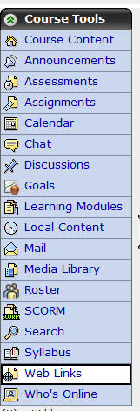



  - Click on the create assignment link within the instructional video.

    - Classify the following components into whether or not they are good components for an online assignment.
Timeline GOOD
Description GOOD
Multiple Ways to complete the assignment NOT
Title GOOD
Unlimited submissions NOT

  - Demonstrate entering an assignment to access the assignment page
_x__ Identify a title in the title box
_x__ Identify a description in the description box
_x__ Identify a timeline for the assignment using the date and time boxes

    - Identify title – Circle the title box in the following screen shot and write the title “Module One” in the title box.
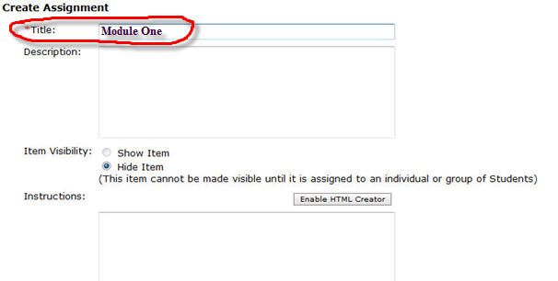
    - Identify description – Circle the description box in the following screen shot and write the description “Reading and Summary Assignment” in the description box.
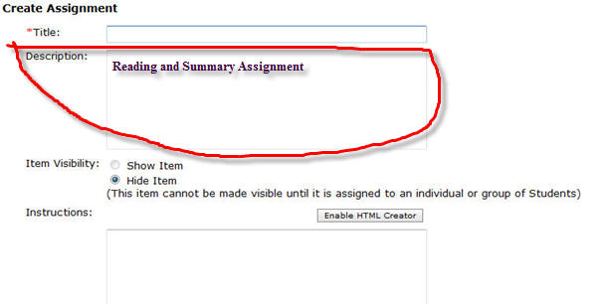
    - Identify timeline – Circle the due date box and due date time box in the following screen shot and write the following due date and due date time “12/10/2008” and “12:00 PM” in the appropriate boxes.
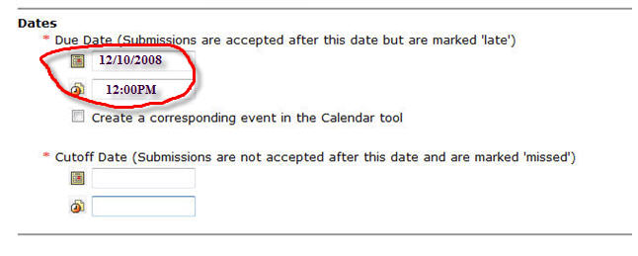

  - Click on the save button at the bottom of the page within the instructional video.

Assessment Checklists and Questions that Accompany the
Creating an Assessment Video

  - Demonstrate how to access the assessment page
_x__ Log on the Blackboard Account
_x__ Access the Course
_x__ Make sure you are in the build tab
_x__ Locate the course tools navigation bar
_x__ Click on the Assessment link

2.1.1 Find the assessment tab by placing a checkmark close to the tab.

  - Click on the create assessment link within the instructional video.

    - Identify title – Circle the title box in the following screen shot and write the title “Module 4” in the title box.
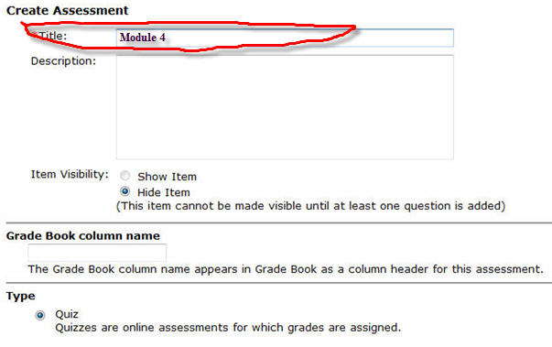

    - Identify description – Circle the description box in the following screen shot and write the description “A four-item assessment.” in the description box.
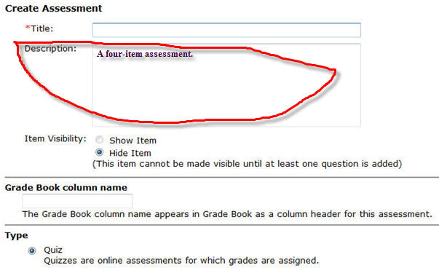
    - Identify timeline – Circle the due date box and due date time box in the following screen shot and write the following due date and due date time “12/10/2008” and “5:00 PM” in the appropriate boxes.
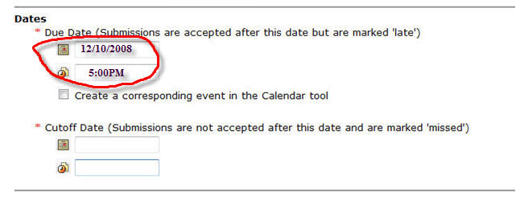

Circle the cutoff date box and cutoff date time box in the following screen shot and write the following cutoff date and cutoff date time “12/12/2008” and “5:00 PM” in the appropriate boxes.
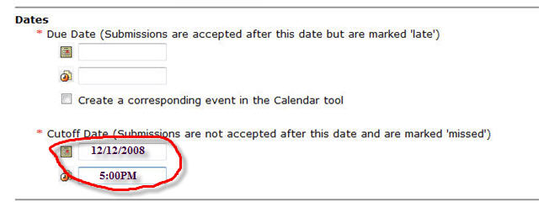
  - Click on the save and add questions button at the bottom of the page within the instructional video.

    - Click on the create question button within the instructional video.

      - Demonstrate creating a matching item using the quiz tool
_x__ Click on the matching link in the drop down menu
_x__ Fill in the title
_x__ Fill in the matching statements
_x__ Fill in the matching answers
_x__ Save the matching item

      - Demonstrate creating a multiple choice item using the quiz tool
_x__ Click on the multiple choice link in the drop down menu
_x__ Fill in the title
_x__ Fill in the multiple choice question
_x__ Fill in the multiple choice answers
_x__ Select the correct multiple choice answer
_x__ Save the multiple choice item

      - Demonstrate creating an open-ended item using the quiz tool
_x__ Click on the short answer link in the drop down menu
_x__ Fill in the title
_x__ Fill in the open-ended question
_x__ Fill in the open-ended answer
_x__ Save the open-ended item

      - Demonstrate creating a true/false item using the quiz tool
_x__ Click on the true/false link in the drop down menu
_x__ Fill in the title
_x__ Fill in the true/false statement
_x__ Fill in the whether the statement is true or false
_x__ Save the true/false item

  - Demonstrate how to save an assessment in the assessment page
_x__ Finish creating all the questions
_x__ Save all the questions
_x__ Select show assessment in assessment page

Assessment Checklists and Questions that Accompany the
Creating an Electronic Calendar

  - Demonstrate how to access the electronic calendar page
_x__ Log on the Blackboard Account
_x__ Access the Course
_x__ Make sure you are in the build tab
_x__ Locate the course tools navigation bar
_x__ Click on the Calendar link

3.1.1 Find the calendar tab by placing a checkmark close to the tab.

  - Click on the add entry link within the instructional video.

Assessment Checklists and Questions that Accompany the
Creating an Assignment Entry in the Electronic Calendar

      - Click on the add entry button within the instructional video.

        - Identify title – Circle the title box in the following screen shot and write the title “Module 3 Team Activity” in the title box.
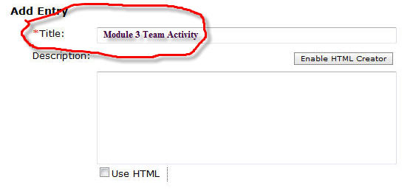
      - Schedule an assignment due date on the electronic calendar.
_x__ Identify the start date
_x__ Identify the end date
_x__ Identify course with public access entry type

        - Identify Start Date for assignment calendar entry - Circle the start date box and the start date time box and write the following start date and start date time in the appropriate boxes, “12/4/2008”and “12:00 PM” for the assignment.
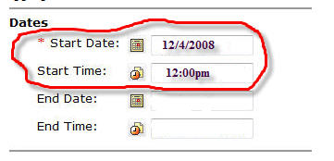
        - Identify End Date for assignment calendar entry - Circle the end date box and the start end time box and write the following end date and end date time in the appropriate boxes, “12/10/2008”and “11:59 PM” for the assignment.
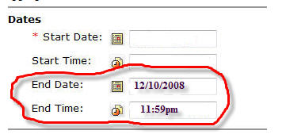

        - Identify course with public access entry type - Circling the course and public entry types.
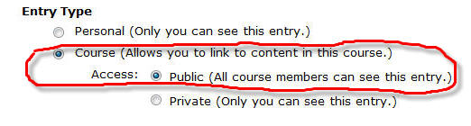

      - Demonstrate creating a hyperlink between the calendar entry and the assignment in the assignment page.
_x__ Click on More Options
_x__ Click on the Add Content Link
_x__ Select Assignments
_x__ Select the Assignment “Module 3 Team Activity”
_x__ Click Add Selected

      - Click on the save button within the instructional video.

Assessment Checklists and Questions that Accompany the
Creating an Assessment Entry in the Electronic Calendar

      - Click on the add entry button within the instructional video.

        - Identify title – Circle the title box in the following screen shot and write the title “Module 3 Quiz” in the title box.
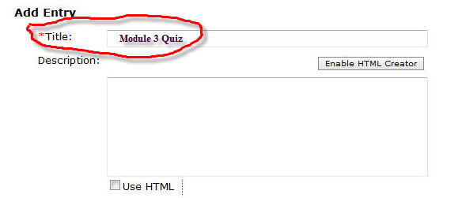
      - Schedule an assignment due date on the electronic calendar.
_x__ Identify the start date
_x__ Identify the end date
_x__ Identify course with public access entry type

        - Identify Start Date for assessment calendar entry - Circle the start date box and the start date time box and write the following start date and start date time in the appropriate boxes, “12/3/2008”and “8:00 PM” for the assessment.
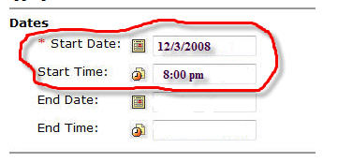
        - Identify End Date for assessment calendar entry - Circle the end date box and the start end time box and write the following end date and end date time in the appropriate boxes, “12/4/2008”and “8:00 PM” for the assessment.
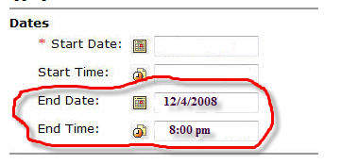

        - Identify course with public access entry type - Circling the course and public entry types.

      - Demonstrate creating a hyperlink between the calendar entry and the assignment in the assignment page.
_x__ Click on More Options
_x__ Click on the Add Content Link
_x__ Select Assessments
_x__ Select the Assessment “Module 3 Quiz”
_x__ Click Add Selected

      - Click on the save button within the instructional video.
Final Assessment (Post-Assessment of the Terminal Objective)

At this point you should have completed the instructional module and all the assessments for each of the videos. Your task at this time is to create an assignment, and assessment, and an electronic calendar using your Blackboard Vista LMS account using the following checklist below to track your progress.

The answers to this section is simply have checkmarks by all the procedures and you have successfully completed the final assessment.

Create an assignment using a LMS with information from a pre-existing assignment that you have developed.

___ Demonstrate how to access the assignment page in a LMS
___ Identify the Assignment tab in a LMS
___ Demonstrate how to create an assignment
___ Classify a good assignment
___ Demonstrate entering an assignment to the assignment page in a LMS
___ Identify the title
___ Identify the description
___ Identify a timeline
___ Demonstrate how to save an assignment to assignment page in a LMS

Create an assessment using a LMS with information from a pre-existing assessment.

___ Demonstrate how to access the assessment page in a LMS
___ Identify the assessment tab in a LMS
___ Demonstrate how to create an assessment
___ Identify a title for the assessment
___ Identify a description for the assessment
___ Identify a timeline for the assessment
___ Demonstrate entering an assessment to the assessment page in a LMS
___ Create a four-item assessment
___ Demonstrate creating a matching item using the quiz tool
___ Demonstrate creating a multiple choice item using the quiz tool
___ Demonstrate creating an open-ended item using the quiz tool
___ Demonstrate creating a true/false item using the quiz tool
___ Demonstrate how to save an assessment to the assessment page in a LMS

Create an electronic calendar using a LMS.

___ Demonstrate how to access the electronic calendar page in a LMS
___ Identify the calendar tab in a LMS
___ Demonstrate how to schedule an event on the electronic calendar
___ Demonstrate how to schedule an assignment in the electronic calendar
___ Demonstrate entering the assignment event to the electronic calendar
___ Identify a title for the event
___Demonstrate how to schedule the assignment due date
___ Identify start date for the calendar entry
___ Identify end date for the calendar entry
___ Identify course with public access entry type
___ Demonstrate how to link a calendar event to the assignment
___ Demonstrate how to save the calendar event
___ Demonstrate how to schedule an assessment in the electronic calendar
___ Demonstrate entering the assessment event to the electronic calendar
___ Identify a title for the event
___Demonstrate how to schedule the assessment due date
___ Identify start date for the calendar entry
___ Identify end date for the calendar entry
___ Identify course with public access entry type
___ Demonstrate how to link a calendar event to the assessment
___ Demonstrate how to save the calendar event

